Architecture

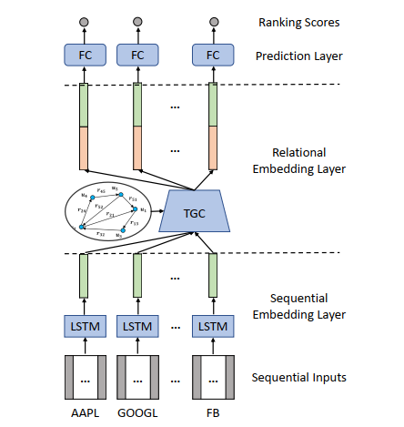

**Input:**

**1. $X^{t}∈R^{NxSxD}={\left[X_{1}^{t},…., X_{N}^{t}\right]}^{T}$ prices of N stocks over S time with D features (input to the framework)**

**2. $A∈R^{NxNxK}$ K: Number of relationships between 2 stocks**

**3. $E^{t}={\left[e_{1}^{t},…, e_{N}^{t}\right]}^{T}∈R^{NxN}$ results from the sequential embedding layer**

**4. $\overline{E^{t}}={\left[\overline{e_{1}^{t}}, …\overline{e_{N}^{t}}\right]}^{T}∈R^{NxN}$ results from the relational embedding layer**

**5. $r^{t+1},\hat{r^{t+1}}∈R^{N}$ Truth and predicted rankings**

**1. Sequential Embedding Layer:**

* Uses LSTMs to capture stock price trends over time.
* Long-term dependencies are crucial for prediction due to macroeconomic effects and mean reversion.

2. **Relational Embedding Layer:**

* Incorporates stock relationships (e.g., same industry, supply chain links).
* Uses **Temporal Graph Convolution (TGC)** to adjust embeddings dynamically based on relations.

**3. Prediction Layer:**

* Combines sequential and relational embeddings.
* Uses a **ranking-based loss function** to optimize both absolute return prediction and relative ranking.

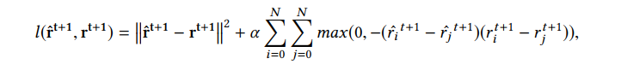

**Temporal Graph Convolution (TGC):**

* Generalizes **Graph Convolutional Networks (GCN)** to handle **time-sensitive** stock relationships.
* Embeddings propagate via three methods: **Uniform, Weighted, and Time-aware propagation.**
* Can be modeled **explicitly** (using similarity & relation importance) or **implicitly** (via neural networks).